Friend Class

#include<iostream>
using namespace std;

class XYZ
{
private:
char ch='A';
int num=11;
public:
friend class ABC;
};

class ABC
{
public:
void disp(XYZ obj)
{
cout<<obj.ch<<endl;
cout<<obj.num<<endl;
}

};

int main()
{
ABC obj;
XYZ obj2;
obj.disp(obj2);
return 0;
}

output:

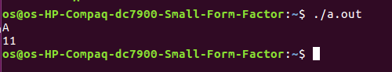

Friend Function

#include<iostream>
using namespace std;
class Box
{
private:
int length;
public:
Box():length(0){}
friend int printlength(Box);
};

int printlength(Box b)
{
b.length+=10;
return b.length;
}

int main()
{
Box b;
cout<<"Length of box:"<<printlength(b)<<endl;
return 0;
}

Output:

